Please note that this information is strictly embargoed until November 10, 2022, 10:00 CET

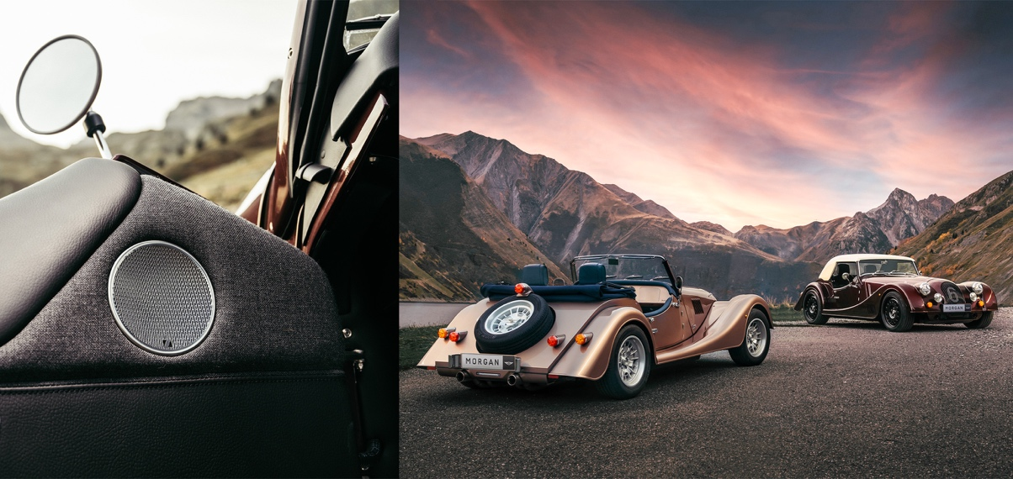

Sennheiser brings outstanding audio system to Morgan’s new Plus models

Technology partnership between audio specialist and British sports car manufacturer delivers premium audio quality to Plus Four and Plus Six

Wedemark, November 10, 2022 – British motor car manufacturer, Morgan Motor Company, has partnered with Sennheiser to develop a revolutionary audio system specially for its new Plus Four and Plus Six models. Whilst Morgan sports cars have featured audio systems in the past, the audio experience of the Sennheiser offering far surpasses anything that has come before it. The Sennheiser sound system delivers an enveloping sound with a unique soundstage that takes audio fidelity to its highest level.

“Our unique technology, and the skill and expertise of our team working alongside the incredible team at Morgan has made it possible for an open-top sports car to have a sound system that delivers on every level,” says Sennheiser joint CEO, Dr. Andreas Sennheiser.

“The new Morgan Plus line celebrates the essence of unconventional driving and ethical engineering. It unites timeless design and craftsmanship with appropriate modern technology,” says Massimo Fumarola, CEO, Morgan Motor Company. “The introduction of revolutionary new audio, thanks to the expert team at Sennheiser, delivers on our promise to continually evolve our products, introducing the latest technology throughout. We are excited to partner with Sennheiser and look forward to continuing our partnership.”

Sennheiser has more than 75 years of experience in audio and is a global leader in professional technology. This makes it a perfect match for the Morgan Motor Company, which has been manufacturing quintessentially British vehicles for more than 110 years, combining an exceptional mix of traditional craftsmanship and modern technology. The result blends a clear focus on design with technological excellence in a system that features Sennheiser’s signature sound, aligning with the sports car manufacturer’s unique blend of craft, adventure, and analogue driving experience.

Sennheiser’s tuning creates the magical illusion of a sound stage in front of the passengers, providing a high-quality soundtrack to those unforgettable drives. Thanks to the AMBEO Contrabass algorithm, the audio system delivers a unique bass response optimized for definition, punch, and depth while keeping the system as efficient and compact as possible.

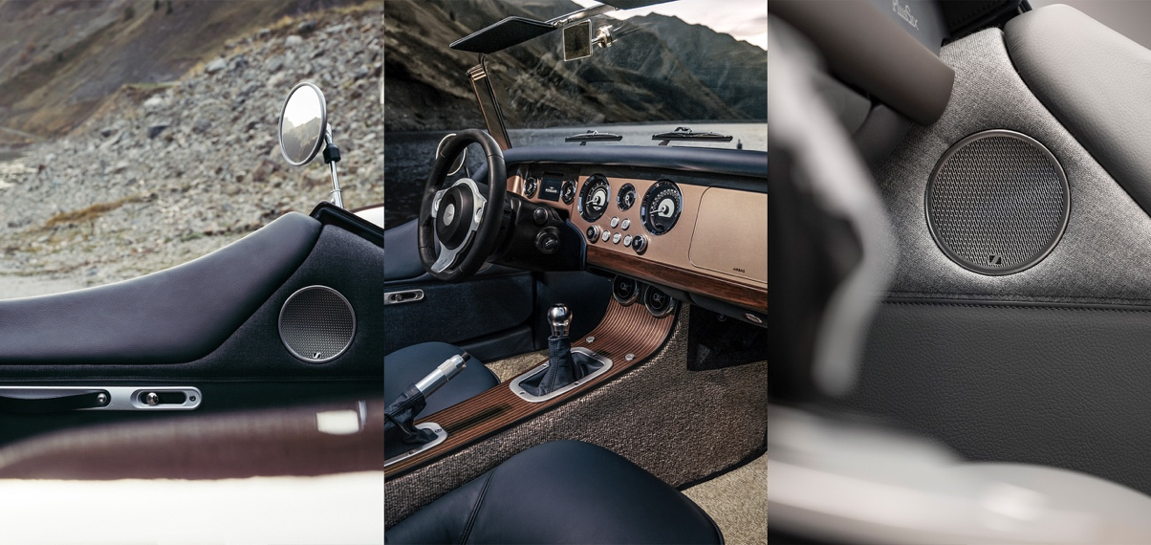

The system includes eight transducers: four conventional speakers in the door and rear panel, and four invisible speakers, of which three are behind the dashboard and one in the lower compartment panel for bass reproduction. The transducers are controlled by a new amplifier with a dedicated DSP, powered by Sennheiser’s audio processing software.

The integration has been carried out in line with Morgan’s key philosophy of appropriately introducing modern technology into its vehicles. The cabin design is unaltered, and the use of invisible speakers ensures that additional weight is kept to a minimum, a must for any sports car. Even under the demanding conditions of an open-top sports vehicle, this system maintains premium sound quality.

Visual cues arrive in the form of subtle Sennheiser branding, visible on the speaker grille situated on each door. The design of the speaker grilles takes inspiration from the iconic Morgan louvres that are stamped into each bonnet of Plus models. Each speaker grille is finished in polished satin, coordinating with other embellishers visible within the cockpit of the vehicle.

“This is an exciting collaboration between two historic firms that results in unique products of exceptional sound quality, design, and craftsmanship. We really enjoyed working on the project, and we look forward to further great ventures with the Morgan team!” concludes Dr. Andreas Sennheiser.

(Ends)
The images accompanying this press release and additional photos can be downloaded here.

About the Sennheiser brand
We live and breathe audio. We are driven by the passion to create audio solutions that make a difference. Building the future of audio and bringing remarkable sound experiences to our customers – this is what the Sennheiser brand has represented for more than 75 years. While professional audio solutions such as microphones, meeting solutions, streaming technologies and monitoring systems are part of the business of Sennheiser electronic GmbH & Co. KG, the business with consumer devices such as headphones, soundbars and speech-enhanced hearables is operated by Sonova Holding AG under the license of Sennheiser.

www.sennheiser.com
www.sennheiser-hearing.com

Global Pro Audio Press Contact

Stephanie Schmidt
Stephanie.schmidt@sennheiser.com
+49 (5130) 600 – 1275

About Morgan Motor Company
Morgan Motor Company has been handcrafting sports cars since 1909 and is one of the world's pre-eminent coachbuilders. Pioneering its unique blend of traditional craftsmanship and modern technology, every Morgan is handmade to order.
The historic home of Morgan is at Pickersleigh Road in Malvern Link, Worcestershire. This is the only place in the world where Morgan cars are built. Steeped in history, the hallowed red brick buildings are home to one of the most unique automotive production facilities in the world.

Morgan sports cars are hand crafted using three core elements: ash, aluminium, and leather. Every car is entirely unique, built to the highest standards by passionate craftsmen and women, whose skills are handed down through generations and perfected over a lifetime, bringing together heritage, innovation, and cutting-edge technology.

Morgan's model line-up comprises Super 3, Plus Four and Plus Six. Characterised by its analogue driving experience, whichever model you choose, every journey in a Morgan is an adventure.

For further information please contact:

James Gilbert
Email: james.gilbert@morgan-motor.co.uk
Phone: +44 (0) 1684 580151
Web: https://media.morgan-motor.com

